A Proposal for IOT Based Smart Transportation Payment and Monitoring

Computer science and engineering department

graduating project

2021

Contents

Chapter One: Introduction 3

1. Background of the project 3

2. Statement of the problem 3

3. Justification of the project 4

4. Objective of the project 4

a) General Objective 4

b) Specific Objective 4

5. Scope and Limitation 4

a) Scope of the study 4

6. Assumptions made in the project 4

7. Limitation of the project 5

8. Feasibility Study 5

a) Technical Feasibility 5

b) Operational Feasibility 6

c) Economic Feasibility 6

9. Significance of the project 6

10. Beneficiaries of the project 6

11. Methodology 6

a) Data collection methodology 6

b) Development tools 7

12. Required resource with cost 7

13. Task and Schedule 7

14. Team composition 8

Chapter 2: Existing Systems 9

2.1 Major function of existing system 9

2.2 Users of current System 9

2.3 Drawback of current System 9

Chapter 3: Proposed System 10

3.1 Overview 10

3.2 Functional Requirement 10

3.3 Non-functional Requirement 10

3.4 System Model 10

# Chapter One: Introduction

## Background of the project

Transport has evolved in history, following a wide range of drivers, which changed how, how much, when, and why people moved and transported goods between places. Mobility demand has always been driven by the need to access opportunities, related to work, services, shopping or leisure, depending on the specific historical and cultural context.

Transportation has been a country’s scale of civilization for centuries and will continue to be one for the years to come. People have moved from the simple cattle transportation to the sophisticated airplane and jets.

Digitizing the interaction of the passengers with the transportation system they chose is becoming the new norm. However, As Africans we are far behind and will need to work on our digitizing speed to catch up with the rest of the world.

The progress of global urbanization, especially in developing countries, is leading to an increased need in digitized and urban-metro transport solutions. As a result, automatic payment system for transportation has become a priority for public transport in large and medium-sized cities and generated large demand in other developed countries.

## Statement of the problem

This outstanding capacity of the project aims to address various problems such as physical payment, tariff control, route allocation difficulties and mainly, it improves the traditional payment systems used in the public transport context.

Another outstanding property consists of the reduction of the operation costs thanks to

two factors: the use of local communication infrastructures and the use of general

purpose devices, avoiding devices based on proprietary technology. Finally, we have

based our model on the ubiquitous paradigm, to achieve the initial objectives

of the system; specifically, regarding flexibility and scalability. As a final consequence

we can affirm that this paradigm provides techniques and ideas which can improve

the traditional payment systems.

## Justification of the project

Transportation is one part to build smart city. Among industry sectors that are rapidly adopting IoT technology, public transportation is one that can benefit the most from gains in operational efficiencies, cost savings, safety and security. for efficient tariff control, balance vehicle distribution,

These days COVID-19 is the big issue in all countries, so our system is working on combating this nationwide crisis by trying to minimize personal contact through money exchange etc.

Until now there is no launched IOT based transportation payments system in our country. So, our system will overcome problems that we have in transportation area.

The side effects are our country stack on the old transport payment system. That affects the stockholders.

## Objective of the project

### General Objective

The general objective of the project is to address the transportation problem of inefficiency. This will be achieved with a semi-automated system consisting of web, android and IOT technology.

### Specific Objective

The main objectives of this project are to prototype an automatic payment system through rechargeable cards or QR code, real-time route measurement with user trend analysis, and lastly, tariff and tax enforcement mechanism.

## Scope and Limitation

### Scope of the study

The scope of this project is the deployment of a payment and monitoring system for public transport providers like busses with in the geographic area of Addis Ababa. The project will consist of the backend implementation of a backend system to manage the database, a mobile application and a web app for user interaction and IOT based smart card payment system for the payment. Although the payment method is as stated above, it is also possible to integrate other payment systems if the need arises or the primary one becomes compromised for any reason.

## Assumptions made in the project

1. All team members have or can acquire easily the skills necessary to build the system.
2. We have all the necessary hardware and software tools
3. The working space is available 24/7
4. Policies and regulation of the Ethiopian government allows such system to be implemented
5. Guidance and supervision are provided from Computer Science and Engineering department of ASTU research lab
6. The system will only be executed inside the scope

## Limitation of the project

**Resistance from transport service providers**

It is to be expected that this project will be met with a significant level of resistance from the transport service providers. There are various established norms and ways of working with in the community. In some ways this might appear to pose a threat and therefor be met with resistance stemming from self-preservation. For this resistance to subside, the system needs to take account for the wants and needs of the transport service providers.

**Users’ hesitation to adopt new payment system**

Since the start of the public transportation system people have always paid with cash. This is both convenient and ubiquities. Even in the age we live in, cash is the default for most if not all users of public transportation. As such, for the conversion to this system there needs to be a convincing value proposition for the users and an increase of the ubiquity of the system.

**Device theft**

As this system requires some kind of computing device onboard the transportation vehicles, it is highly vulnerable to theft. This needs to be taken into account in the physical design of the device and the development of the software. The installation point also has a factor to play to the susceptibility of the device for theft.

## Feasibility Study

### Technical Feasibility

From a technical point of view, the feasibility of this project is high because of the following reasons.

* + - 1. The underlying tech is reasonably with in the expertise of this team and therefor with in the expertise of the Ethiopian tech community.
      2. No unreasonably expensive or rare tools and equipment are used in this project. All of the tools and equipment are readily available with in the Ethiopian and the international market.

### Operational Feasibility

From an operational point of view, the feasibility of this project is high because of the following reasons.

The technology that is required to operate the product is easily learnable and easy to deploy.

The utility services that the product might need to connect to are readily available with in the intended deployment area and the system also has redundancies to continue functioning even if that is not the case.

### Economic Feasibility

From an operational point of view, the feasibility of this project is high because of the following reasons.

1. The equipment needed to deploy said product is with in the affordability range when assembled with off the shelf electronic components. This indicates if the product was ever to be mass produced on custom circuit boards, domestic or overseas, it will be significantly cheaper to produce, deploy and run the operations for all users and stakeholders alike.
2. The ROI (return on investment) for both the government and transportation providers is reasonable by current estimates. This opens the door for a whole host of deployment strategies. For example, the government can help with the purchase of the devices with a long-term repayment arrangement.

## Significance of the project

## Beneficiaries of the project

1, Transport service providers

2, Passengers

3, Ethiopian Revenue and Customs Agency

## Methodology

### Data collection methodology

The Data Collection for this project will be conducted by way of **interviews**, **questionaries** and **requests for data from governmental and non-governmental organizations**. These can be, for all intensive purposes, called stakeholders of the project.

* Transport Ministry
* Passengers
* Addis Ababa City Administration
* Sheger Bus
* Ambesa Bus
* Traffic Police

### Development tools

The development tools to be used in the execution of this project are as follows.

* **Laravel**: backend development
* **Flutter**: frontend development
* **Raspberry pi**: for IOT testing and deployment
* **Vue JS**: Frontend development
* **Trello**: Task management

## Required resource with cost

## 

|  |  |
| --- | --- |
| **Item** | **Cost** |
| Raspberry pi 3 B+ | 3000 birr |
| RFID scanner and reader (RFID-RC522) | 500 birr |
| RFID card | 250 birr |
| GPRS Module | 1000 birr |
| Gps Module | 2000 birr |
| 16x2 LED display | 700 birr |
| 4x3 keypad | 600 birr |
| **Total** | 8050 birr |

## Task and Schedule

|  |  |  |  |
| --- | --- | --- | --- |
| Task | Due | Activities | Person in charge of overseeing operation |
| Documentation |  |  |  |
| Chapter 1 | March 18 | Requirement gathering,  Market research, Literature review | Yohanes and Tihitena |
| Chapter 2 & 3 | April 9 |  | Tigist |
| Chapter 4 & 5 | April 30 |  | Bemnet and Nebiyu |
| Final Documentation | May 5 | Revision | Yohanes and Tihitena |
| Prototype |  |  |  |
| Architecture Design |  |  | Bemnet and Nebiyu |
| Front-End Design and development |  |  | Tihitena |
| Back-End development |  |  | Nebiyu |
| IOT design and development |  |  | Bemnet |
| API development |  |  | Yohanes |
| Integration |  |  | Tigist |
| Deployment |  |  | Yohanes |
| Defence |  |  |  |
| Rehearsal |  |  |  |
| Defence |  |  |  |

## Team composition

|  |  |
| --- | --- |
| Name | Role |
| Yohanes Fikru | Team Leader |
| Tihitina Mesfin | Frontend developer |
| Bemnet Nikodimos | Mobile development and IOT develomernt |
| Nebiyu Adem | Backend developer |
| Tigist | System Integrator |

# Chapter 2: Existing Systems

## 2.1 Major function of existing system

The current existing systems that this project is aiming to improve, replace or augment are as following.

1. Payment system

* The current payment system is manual as the assistant collects the payment from the passengers.

1. fleet management

* The current fleet management is manual as the transportation vhivles are assigned a route by the transport administrator and the tariff control personal at the stations make sure the vhivles follow their routes.

1. Security
2. police (highly delayed)

- If a passenger loses something or if an incident happens then the passengers can make a police report for the incident to be investigated.

## 2.2 Users of current System

The users of the current system are as follows.

1. Passengers
2. fleet control personal
3. transport service providers
4. ERCA
5. Transport Authority
6. Police

## Drawback of current System

The Drawbacks of the current system is as follows

* it's all manual
* inefficient and unfair
  + time usage
  + route allocation
  + transport distribution
  + payment and tax collection
* highly insecure services

# Chapter 3: Proposed System

### 3.1 Overview

### 3.2 Functional Requirement

1. passengers will be able to pay with a swipe
   1. pay for multiple people
2. tariff and tax control
3. account top up
   1. Manual
   2. Web
   3. Mobile
4. fleet control and management
5. theft reporting to authorities

### 3.3 Non-functional Requirement

* Reliability
* Accessibility
* Scalability
* localized
* Secure

### 3.4 System Model

#### 3.4.1 Scenario

**Scenarios**

1. **Sign up for service online**
   1. Actors: Customer
      1. Flow Event:
         1. open mobile/ web app
         2. go to sign up page
         3. input required information
         4. input payment information
         5. make initial payment for card
         6. receive card at card center
2. **Sign up for service in person**
   1. Actors: Customer, clerk
   2. Flow Event:
      1. provide personal information to clerk
      2. provide information to clerk (optional)
      3. receive account ID
      4. make initial payment for card
      5. receive card
3. **transportation payment**
   1. Actors: Customer
   2. Flow Event:
      1. swipe card
      2. input number of people
      3. get in
      4. swipe card at getting off point
4. **Recharge credit online**
   1. Actors: Customer
   2. Flow Event:
      1. open web/ mobile app
      2. login into app
      3. navigate to accounts page
      4. click the recharge button
      5. connect preferred payment method
      6. input amount
      7. authenticate transaction
5. **Recharge credit in person**
   1. Actors: Customer, clerk
   2. Flow Event:
      1. give clerk account ID
      2. specify desired amount for recharge
      3. make payment
      4. receive receipt
6. **revoke card in person**
   1. **Actors: Customer, clerk**
   2. **Flow event**
      1. give clerk account ID
      2. give clerk card ID
      3. get confirmation for card being revoked
7. **revoke card online**
   1. Actors: Customer
   2. Flow Event:
      1. go to card management menu
      2. select card
      3. select revoke card
8. **see travel history**
   1. Actors: Customer
   2. Flow Event:
      1. Go to My Account page
      2. Select Travel History
      3. Select card
9. **set tariff**
   1. Actors: Transport Authority
   2. Flow Event:
      1. login to web app
      2. go to tarriff control
      3. select route
      4. select update tarriff
      5. update tarriff
10. **assign routes**
    1. Actors: Transport Authority
    2. Flow Event:
       1. login to web app
       2. go to route control
       3. select set new route
       4. set starting point and end point
       5. set tarriff
11. **edit route**
    1. Actors: Transport Authority
    2. Flow Event:
       1. login to web app
       2. go to route control
       3. select edit route
       4. select route to edit
       5. change desired information
       6. confirm change
12. **send income report**
    1. Actors: Financial Admin
    2. Flow Event:
       1. login to web app
       2. go to Financial reports menu
       3. go to income statement menu
       4. click "Generate income statement"
       5. cross check income statement with account holder activity
       6. approve income statement
       7. send income statement to ERCA
13. **track transport vehicle fleet**
    1. Actors: Transport Authority
    2. Flow event:
       1. login to web app
       2. go to fleet tracking
       3. authenticate tracking request
       4. view live tracking on map

**3.1. Use case Model**

Use case model is a scenario-based technique in UML which identify the actors in an

interaction and which describe the interaction itself. A set of use cases should describe all

possible interactions with the system.

**3.1.1. Actor identification**

Actors are some people that accomplish use case up on a system

**Name**; Passengers

**Description** - The main emphasis of the system are the passengers and their interaction to the platform is the most crucial.

**Rule**-Subscribe to the payment system, Pay automatically, view route history

**Name** - ERCA

**Description** - The main emphasis of the system are the passengers and their interaction to the platform is the most crucial.

**Rule**-Views Annual Financial Detail

**Name** - Transport Authority

**Description** – This party will technically own and administer the platform

**Rule** - Manage Customer database, set tariff, assign route

**Name** -Transport Service Provider

**Description** – This party will have less involvement with the system than passengers and Transport Authority as this is a platform designed to control and manage the service provider.

**Rule** - set an account for payment collection, view route history

* + 1. **Use cases description**

|  |  |
| --- | --- |
| Use-case name | Sign up for service online |
| Use-case ID | 1 |
| Use-case description | Registers new users to be subscribers to the platform |
| Actor | Passengers |
| Pre-Conditions | The Passenger commits to either pre or post payment methods |
| Post-Conditions | The passenger is a subscriber of the system |
| Main flow | 1. Initiates the platform 2. Opens form 3. Fills in important information 4. Confirms subscription |
| Exceptional flow | Passenger is unable to confirm subscription |
| Include | View Confirmation or failure message |
| Frequency of use | Correspondence to the number of subscribers |

Table: *Use case description for sign up for service online*

|  |  |
| --- | --- |
| Use-case name | Sign up for service in person |
| Use-case ID | 2 |
| Use-case description | Registers new users to be subscribers to the platform through agents |
| Actor | Passengers |
| Pre-Conditions | The Passenger commits to either pre or post payment methods |
| Post-Conditions | The passenger is a subscriber of the system |
| Main flow | 1. Fill in important information 2. Confirm subscription |
| Exceptional flow | Passenger does not have proper identifications |
| Include | Payment receipt |
| Frequency of use | Correspondence to the number of subscribers |

Table: *Use case description for sign up for service in person*

|  |  |
| --- | --- |
| Use-case name | Transportation automatic payment |
| Use-case ID | 3 |
| Use-case description | Deducts money from subscribers account based on tariff and distance |
| Actor | Passengers |
| Pre-Conditions | * The account has enough balance * The card used (if the passenger is using card) is not defected * The QR code is not deactivated (if the passenger is using QR code) |
| Post-Conditions | Payment is made for the distance travelled based on the tariff set by the transport authority |
| Main flow | 1. Swipe card at the beginning of the journey 2. Fill in the number of travellers using that particular card for that ride 3. Swipe once again up on arrival of the destination, so the system calculates the distance travelled |
| Exceptional flow | * Passenger’s account does not have enough balance accounted for that certain travel * The card used is defected * The QR code is deactivated |
| Include | Payment confirmation message |
| Frequency of use | Correspondence to the number of subscribers times the number of travel by each subscriber |

Table: Use case description for Transportation automatic payment

|  |  |
| --- | --- |
| Use-case name | Recharge credit online |
| Use-case ID | 4 |
| Use-case description | Recharges the subscribers account automatically |
| Actor | Passengers |
| Pre-Conditions | * The account exists (the passenger has already subscribed) |
| Post-Conditions | Account is recharged |
| Main flow | 1. Fill in verification code 2. Specify the amount to be recharged 3. Confirm Completion |
| Exceptional flow | * The passenger has forgotten verification details |
| Include | Recharge confirmation message |
| Frequency of use | Correspondence to the number of subscribers times the number of recharge by each subscriber |

Table: *Use case description for Recharge credit Online*

|  |  |
| --- | --- |
| Use-case name | Recharge credit in person |
| Use-case ID | 5 |
| Use-case description | Recharges the subscribers account in person |
| Actor | Passengers, Clerk |
| Pre-Conditions | * The account exists (the passenger has already subscribed) |
| Post-Conditions | Account is recharged |
| Main flow | 1. give clerk account ID 2. specify desired amount for recharge 3. make payment 4. receive receipt |
| Exceptional flow | * The passenger has forgotten verification details |
| Include | Recharge confirmation message |
| Frequency of use | Correspondence to the number of subscribers times the number of recharges by each subscriber |

Table: *Use case description for recharging in person*

|  |  |
| --- | --- |
| Use-case name | revoke card in person |
| Use-case ID | 6 |
| Use-case description | Revoke the subscribers account in person |
| Actor | Passengers, clerk |
| Pre-Conditions | * The account exists (the passenger has already subscribed) * The card is lost, stolen or defected |
| Post-Conditions | Account is revoked |
| Main flow | 1. give clerk account ID 2. give clerk card ID 3. get confirmation for card being revoked |
| Exceptional flow | * The passenger has forgotten verification details |
| Include | * Revoke confirmation message * Re-activate Revoked the account |
| Frequency of use | Depends on the number of times a card is lost, stolen, defected or out of use for different reasons |

Table: *Use case description for recharging in person*

|  |  |
| --- | --- |
| Use-case name | revoke card online |
| Use-case ID | 7 |
| Use-case description | Revoke the subscribers account in online |
| Actor | Passengers |
| Pre-Conditions | * The account exists (the passenger has already subscribed) |
| Post-Conditions | Account is revoked |
| Main flow | * + 1. go to card management menu     2. select card     3. select revoke card |
| Exceptional flow | * The passenger has forgotten verification details |
| Include | * Revoke confirmation message * Re-activate Revoked the account |
| Frequency of use | Depends on the number of times a card is lost, stolen, defected or out of use for different reasons |

Table: *Use case description for recharging online*

|  |  |
| --- | --- |
| Use-case name | see travel history |
| Use-case ID | 8 |
| Use-case description | Display travel history |
| Actor | Passengers |
| Pre-Conditions | * The account exists (the passenger has already subscribed) |
| Post-Conditions | History is displayed |
| Main flow | * + 1. Go to My Account page     2. Select Travel History     3. Select card |
| Exceptional flow | * The passenger has forgotten verification details |
| Include | - |
| Frequency of use | Depends on the number of times A subscriber wishes to display the history |

Table: *Use case description for displaying travel history*

|  |  |
| --- | --- |
| Use-case name | Set tariff |
| Use-case ID | 9 |
| Use-case description | Set appropriate tariff for each route |
| Actor | Transport Authority |
| Pre-Conditions | * Transport authority has remote access to each vehicle payment device |
| Post-Conditions | Tariff is set to each route |
| Main flow | 1. login to web app 2. go to tariff control 3. select route 4. select update tariff 5. update tariff |
| Exceptional flow | * Any kind of network interruption |
| Include | - |
| Frequency of use | Every time tariff is modified |

Table: *Use case description for setting tariff*

|  |  |
| --- | --- |
| Use-case name | Assign Routes |
| Use-case ID | 10 |
| Use-case description | Allocate vehicles for each route |
| Actor | Transport Authority |
| Pre-Conditions | * Transport authority has remote access to each vehicle control platform |
| Post-Conditions | Route is assigned and communicated to each vehicle |
| Main flow | 1. login to web app 2. go to route control 3. select set new route 4. set starting point and end point 5. set tariff |
| Exceptional flow | * Any kind of network interruption |
| Include | - |
| Frequency of use | Every time tariff is modified |

Table: *Use case description for Assigning Routes*

|  |  |
| --- | --- |
| Use-case name | Edit Route |
| Use-case ID | 11 |
| Use-case description | Edit route and communicate with each vehicle |
| Actor | Transport Authority |
| Pre-Conditions | * Transport authority has remote access to each vehicle control platform |
| Post-Conditions | Route is edited and communicated to each vehicle |
| Main flow | 1. login to web app 2. go to route control 3. select edit route 4. select route to edit 5. change desired information 6. confirm change |
| Exceptional flow | * Any kind of network interruption |
| Include | - |
| Frequency of use | Based on the transport authority schedule |

Table: *Use case description for Editing Routes*

|  |  |
| --- | --- |
| Use-case name | send income report |
| Use-case ID | 12 |
| Use-case description | Send annual income report of each transport service provider to ERCA |
| Actor | Transport Authority, ERCA |
| Pre-Conditions | * Transport authority has remote access to each vehicle control platform |
| Post-Conditions | Annual financial report is calculated and communicated with the concerned party(ERCA in this case) |
| Main flow | * + 1. login to web app     2. go to Financial reports menu     3. go to income statement menu     4. click "Generate income statement"     5. cross check income statement with account holder activity     6. approve income statement     7. send income statement to ERCA |
| Exceptional flow | * Any kind of network interruption |
| Include | - |
| Frequency of use | Annually |

Table: *Use case description for Sending Income Report*

|  |  |
| --- | --- |
| Use-case name | track transport vehicle fleet |
| Use-case ID | 13 |
| Use-case description | Track Each vehicle |
| Actor | Transport Authority |
| Pre-Conditions | * Transport authority has remote access to each vehicle GPS |
| Post-Conditions | Each vehicle is tracked in real time |
| Main flow | 1. login to web app 2. go to fleet tracking 3. authenticate tracking request 4. view live tracking on map |
| Exceptional flow | * Any kind of network interruption |
| Include | - |
| Frequency of use | Realtime |

Table: *Use case description for Track Fleet*

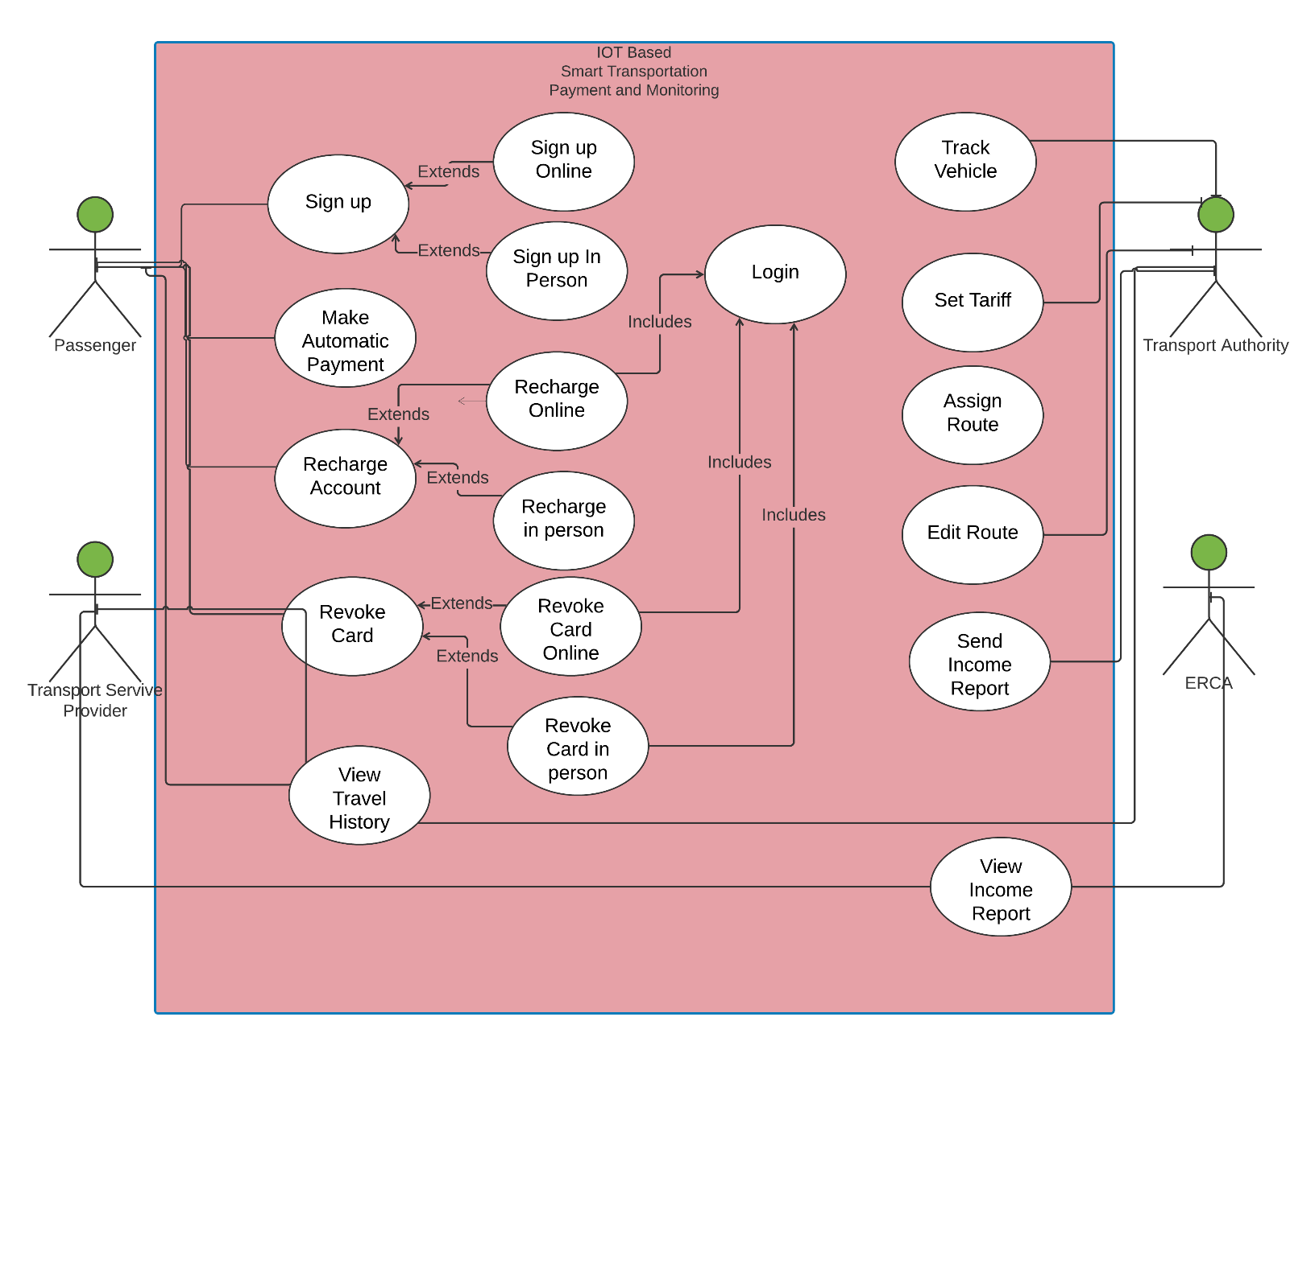

**Use case diagram**

#### 3.4.5 Object Model

#### 3.4.5.1 Class Diagram

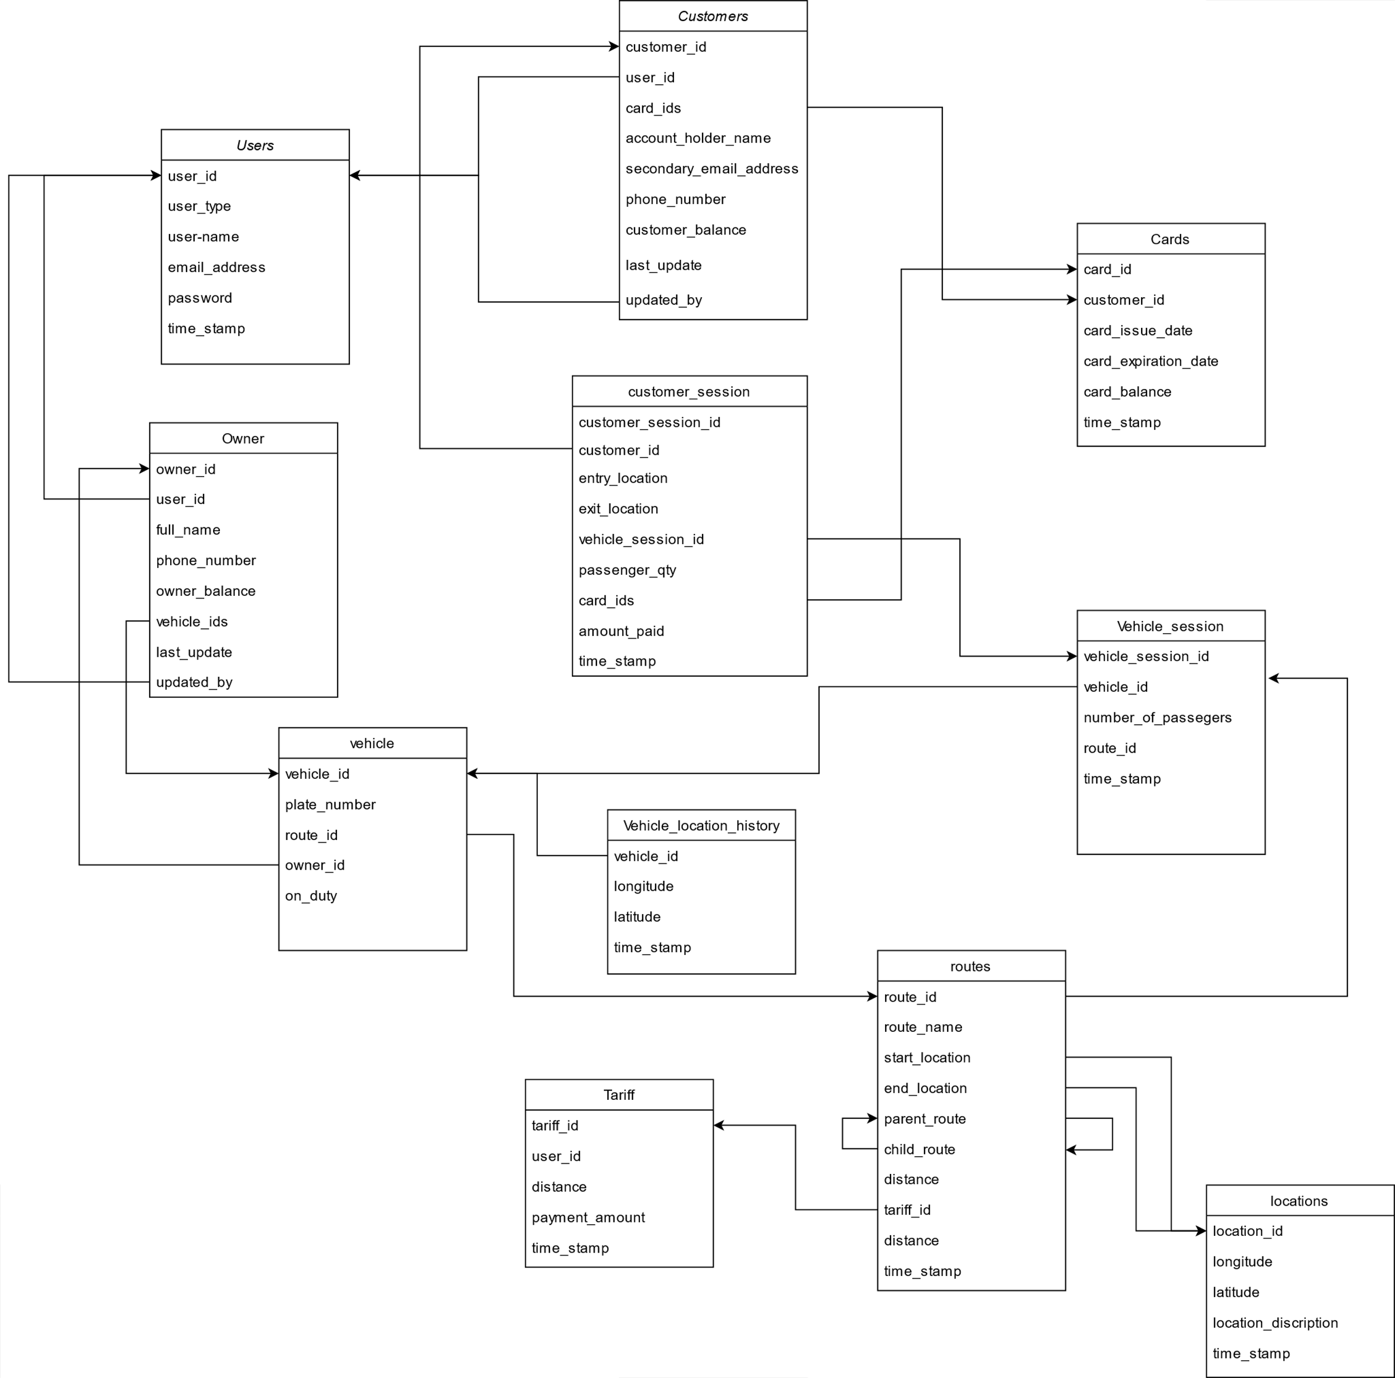

#### 3.4.6 Dynamic Model

#### 3.4.6.1 Activity Diagram

An activity diagram describes a system in terms of activities. Activities are states that represent the execution of a set of operations. The completion of these operations triggers a transition to another activity. Activity diagrams are similar to flowchart diagrams in that they can be used to represent control flow (i.e., the order in which operations occur) and data flow (i.e., the objects that are exchanged among operations).

1. **Sign up for service online**

Actors: Customer

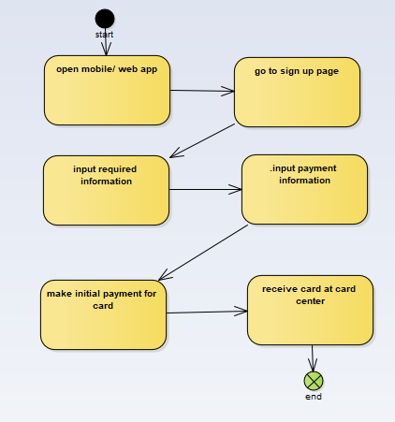

2,  **Sign up for service in person**

Actors: Customer, clerk

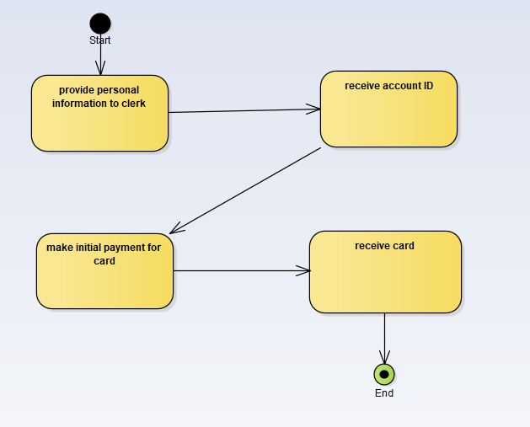

3, **transportation payment**

Actors: Customer

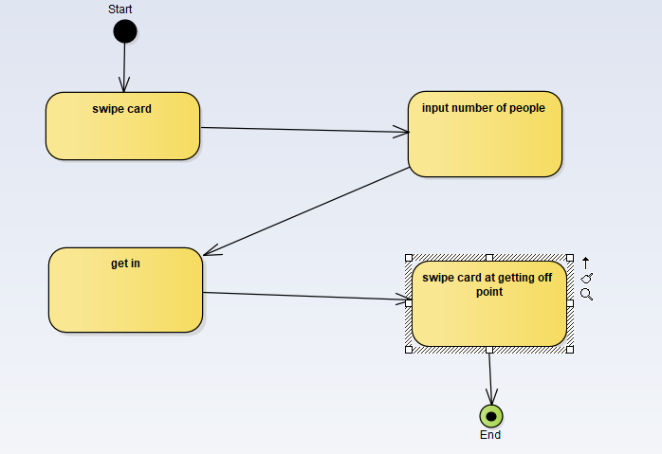

4, **Recharge credit online**

Actors: Customer

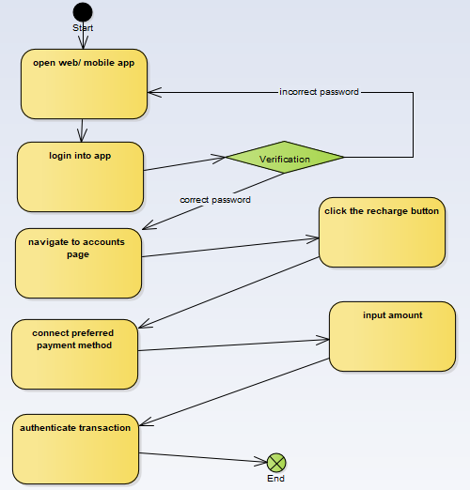

**5, Recharge credit in person**

Actors: Customer, clerk

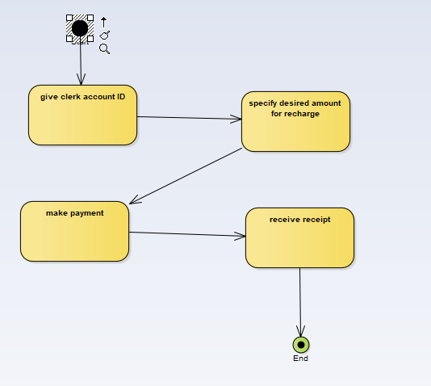

6, **revoke card in person**

**Actors: Customer, clerk**

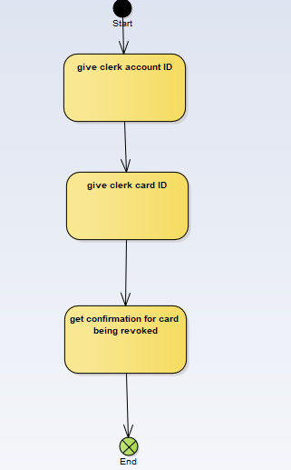

7, **revoke card online**

Actors: Customer



8, **see travel history**

Actors: Customer

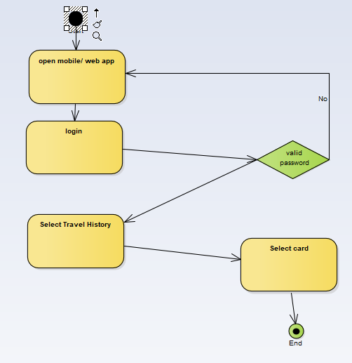

9, **set tariff**

* 1. Actors: Transport Authority

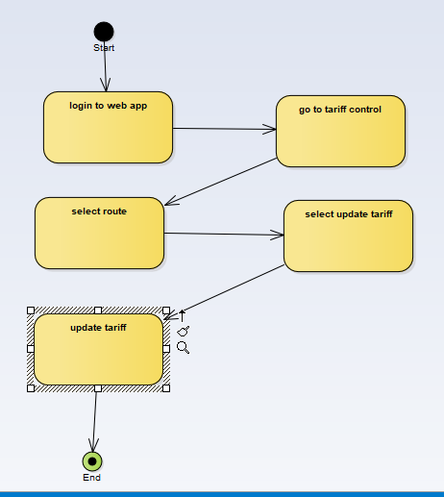

10, **assign routes**

Actors: Transport Authority

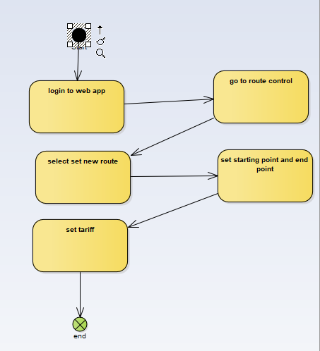

11**, edit route**

Actors: Transport Authority

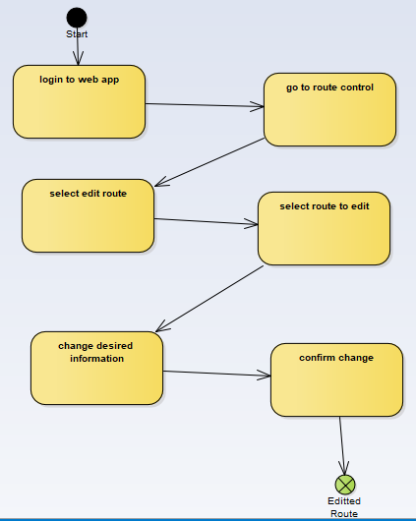

12**, send income report**

Actors: Financial Admin

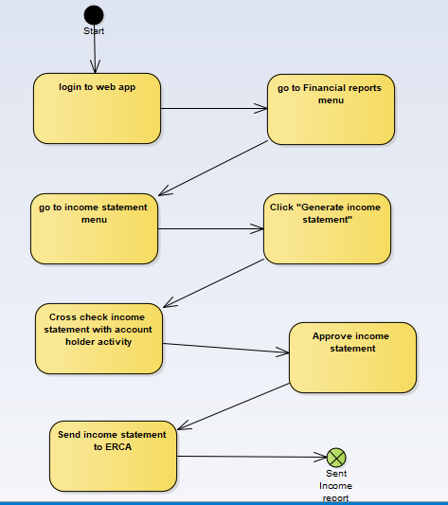

13, **track transport vehicle fleet**

Actors: Transport Authority

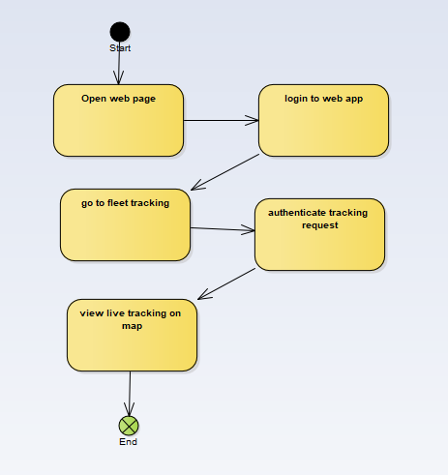

#### 3.4.7 State chart Diagram

**S**tate diagram determines how class process events based on their current state.

Event is any internal or external trigger which causes the system to change its state.

Transition is change in state. It starts from source to its destination.

1. **Sign up for service online**

Actors: Customer

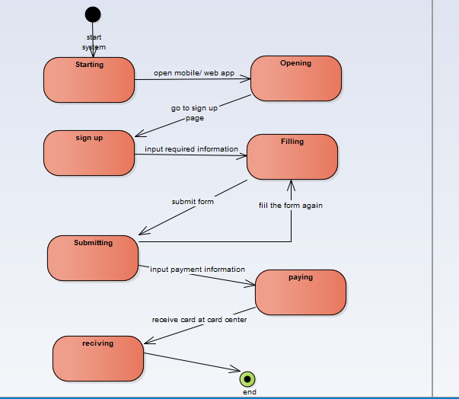

2, **Sign up for service in person**

Actors: Customer, clerk

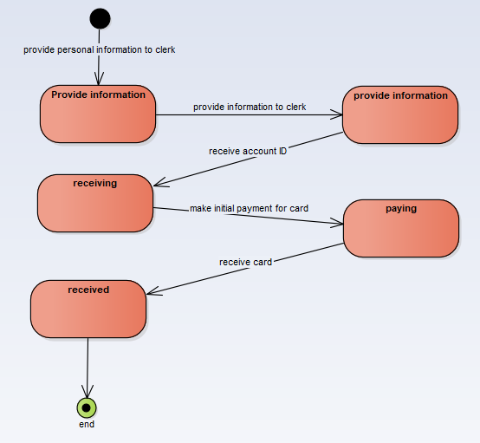

3**, transportation payment**

Actors: Customer

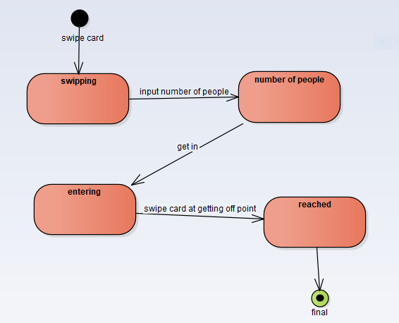

4**, Recharge credit online**

Actors: Customer

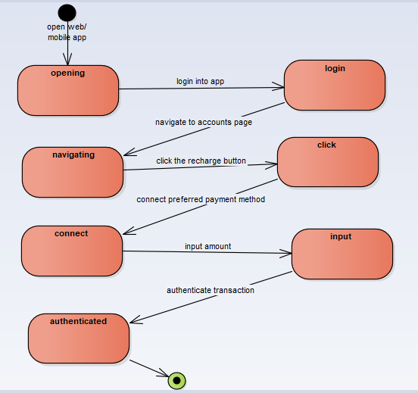

5, **Recharge credit in person**

Actors: Customer, clerk

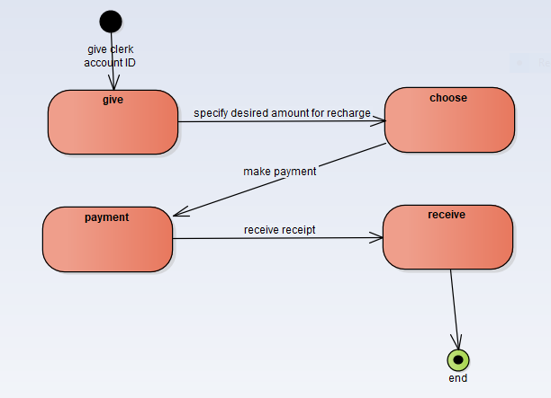

6, **revoke card in person**

Actors: Customer, clerk

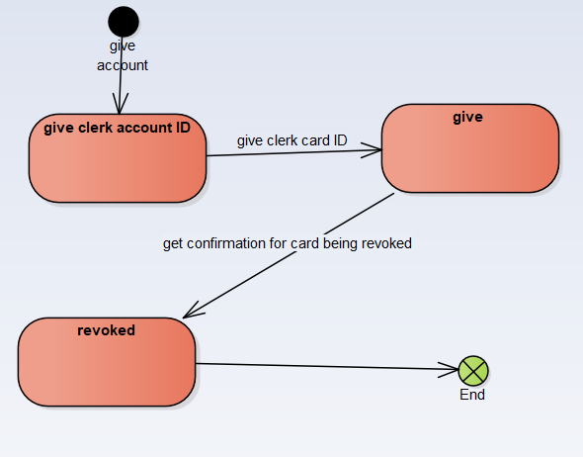

7, **revoke card online**

Actors: Customer

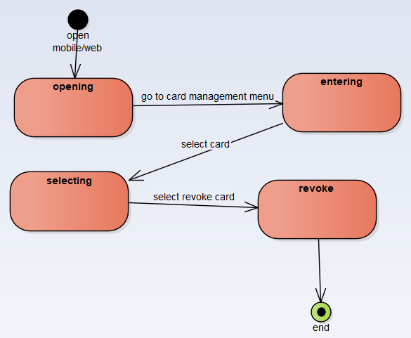

8, **see travel history**

Actors: Customer

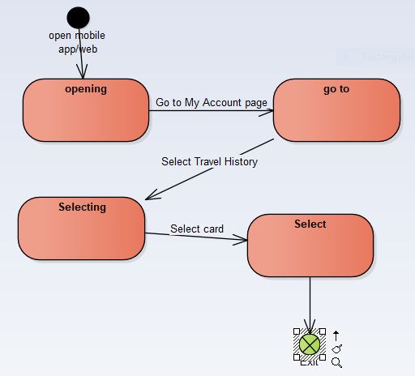

**9, set tariff**

Actors: Transport Authority

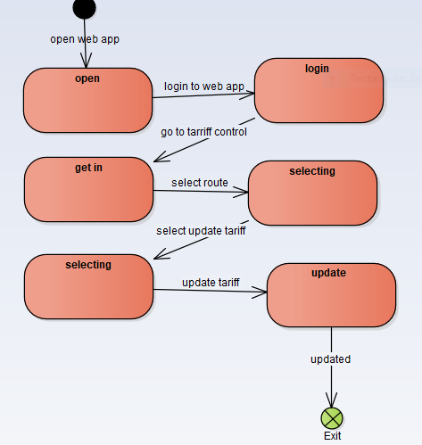

10, **assign routes**

Actors: Transport Authority

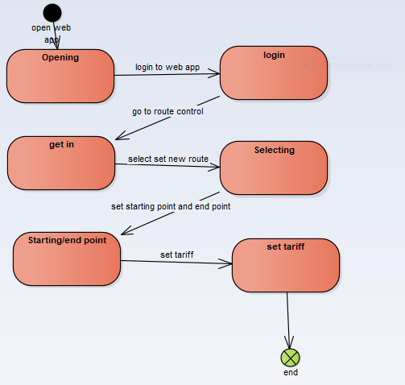

11, **edit route**

Actors: Transport Authority

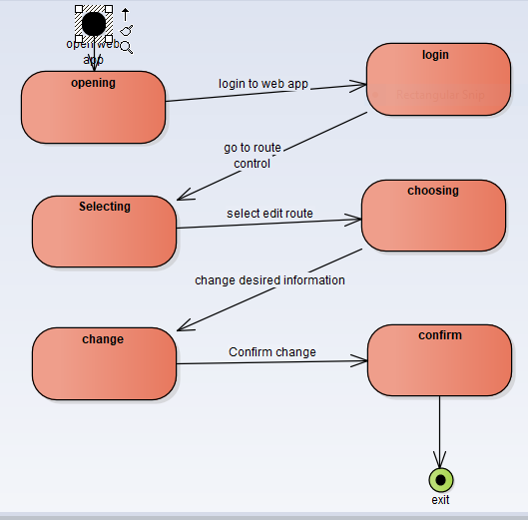

12, **send income report**

Actors: Financial Admin

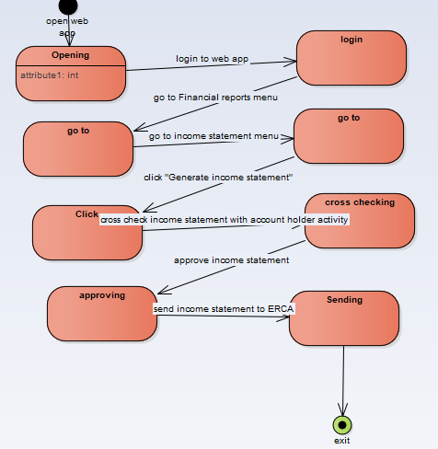

13, **track transport vehicle fleet**

Actors: Transport Authority

